Navigating the AI Adoption in Future Labor : Case of Indonesia

Background
The exponential growth in capabilities shown by Artificial Intelligence (AI) in recent years has spurred an ongoing debate over whether human labor will be replaced by AI. Acemoglu et al. (2023) have argued that artificial intelligence will likely persist, but simply displacing labor would not yield good results for the labor market, and there is no inevitable future of AI development in which we cannot advocate. ​The AI's impact on labor displacement would likely differ across industries. This calls for an analysis which industries would benefit from fully automated jobs or whether a human-centric development of artificial intelligence would be better off for all.
Anthropic recently released a report titled “Anthropic Economic Index Report: Economic Primitives.” (Appel et al, 2026). The report brings a new light to the research on AI and how it shapes current and future labor market. Understanding the risk incurred with the increasing speed of AI adoption across industry and jobs are essential for the business and countries to strategize. Labor across the world will need to adapt and get the optimal benefits while minimizing the potential risks of negative outcome.
This paper will focus on Indonesia and the its adoption rate of artificial intelligence with usage of Claude AI as a proxy. AI adoption in Indonesia will be examined through its usage across different industries and jobs. The data provided will help us understand the current state of AI adoption in Indonesia. This data will then be compared into how labor on average adopt AI in the world.

Literature review
Paper of Anthropic Economic Index Report uses the tasks associated with 800 occupations from the O*NET database, and also the usage data from Anthropic Economic Index to map how AI has been used across industries and countries (Appel et al, 2026).

Preliminary Result
Task penetration is defined as how much AI usage is done on the job. Preliminary result was done by calculating the mean task penetration across job family defined by Anthropic. The diagram shows that in Indonesia, Computer and mathematical still dominates as the job familiy with highest AI usage.
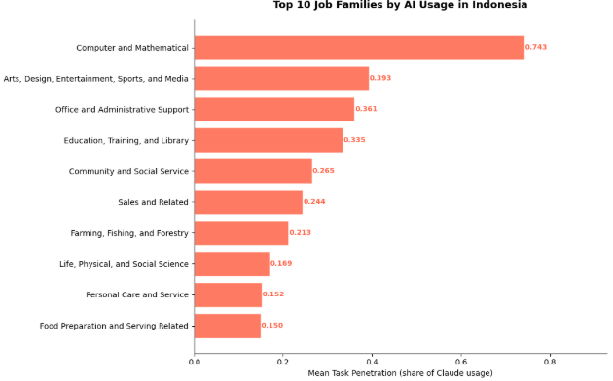
Figure SEQ Figure \* ARABIC 1 Top 10 Job Families by AI Usage in Indonesia

Project Deliverables
The project aims to deliver a thorough analysis of AI adoption in Indonesia has been moving and how it compares with the rest of the world. It aims to provide recommendation to business leaders and government to understand and strategize the changing labor market.

Timeline
Time
Week 1-2 | Exploratory assessment of the trends of AI usage in Indonesia and world
Week 3-4 | -Comparative analysis of Indonesia AI adoption to the world across industries and jobs  - Identify gap and opportunities for industries in Indonesia to adopt AI, strategize labor training
Week 5 | Conclude the analysis of AI Adoption in Indonesia, visualize key insights

References
Acemoglu, Daron, David Autor, and Simon Johnson. 2023. "Can We Have Pro-Worker AI? Choosing a Path of Machines in Service of Minds." Policy Memo, MIT Shaping the Future of Work Initiative, September 19, 2023.
Appel, Ruth, Maxim Massenkoff, Peter McCrory, Miles McCain, Ryan Heller, Tyler Neylon, and Alex Tamkin. 2026. "Anthropic Economic Index Report: Economic Primitives." Anthropic, January 15, 2026. https://www.anthropic.com/research/anthropic-economic-index-january-2026-report.Massenkoff, M., & McCrory, P. (2026, March 5). Labor market impacts of AI: A new measure and early evidence. Anthropic. https://www.anthropic.com/research/labor-market-impacts

